The Lawyer

Irwin Mitchell and Pump Court rule in the discreet world of private client

Private client work is by definition discreet, but The Lawyer’s unique Litigation Tracker data highlights the stars

By Alex Taylor 6 June 2018

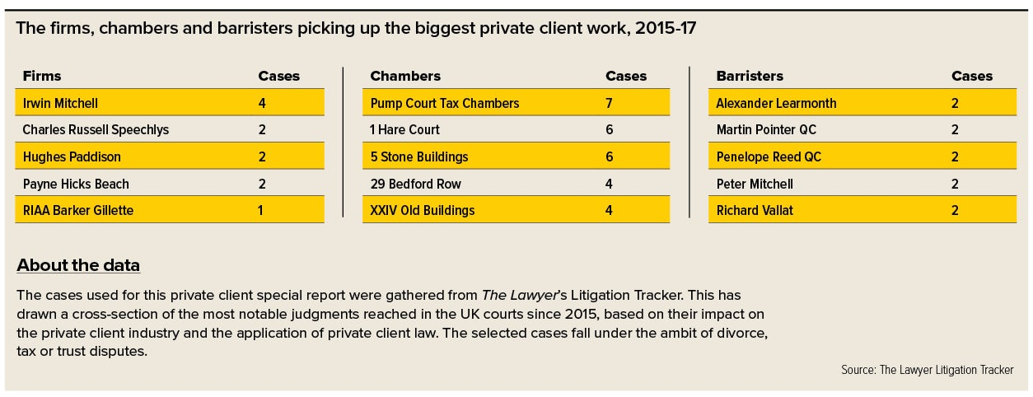

The UK is seen as having a regu­latory atmosphere conducive to private client work, which is why its courts so regularly hear cases and its firms are so active.

Data gathered by The Lawyer’s Litigation Tracker shows Irwin Mitchell to be the most active firm since the tracker’s inception three years ago. Irwin Mitchell has acted in four qualifying cases over that time, and it is followed by three firms with two cases apiece: Charles Russell Speechlys, Payne Hicks Beach and Hughes Paddison.

After these four come 45 firms with a single case each, including major inter­national players such as Hogan Lovells, Latham & Watkins and Clyde & Co ranked level pegging with the more boutique and regional practices of JMW, PCB Litigation and Wright Hassall.

Irwin Mitchell has been the most active firm since the Litigation Tracker’s inception three years ago

The chambers involved follow a similar pattern, providing specialist advice in divorce, tax and trusts.

Among the most active chambers is Pump Court Tax Chambers with seven cases, while Pump Court tenants David Ewart QC, Julian Ghosh QC and Richard Vallat QC are also among the leading barristers in this area – the trio have taken on two cases each since data gathering began.

1 Hare Court and 5 Stone Buildings are joint-second most active chambers in this space with six cases apiece. 1 Hare Court’s Martin Pointer QC and 5SB’s Penelope Reed QC have both been as active as the Pump Court tenants. XXIV Old Buildings and 29 Bedford Row round out the top-five most active chambers, having worked on four cases each in the past three years.

It is clear that a certain type of chambers is emerging from the private client legal world. The top five illustrate a cross-section of the kind of work being done in this unique space.

While some of the most prestigious sets take on this work – Blackstone Chambers and Brick Court feature in the rankings with two matters each – it is clear that this is a specialist field requiring specialist advice.

Where art meets legal advice

Much of the work carried out in this area concerns private art collections. Forsters takes this aspect so seriously that the firm has established a cross-sector group between its private client and corporate practices handling dedicated advice to individuals with high-value art collections.

As one source puts it: “When someone’s got more money than they can spend and their children are being properly looked after, sometimes the only thing to spend their money on is art.”

Mishcon de Reya is among the firms active in the art space, and practice head James Libson has been particularly busy advising clients on art fraud.

Whether it forms a crucial part of the firm or is used as a way to win new clients, private client continues to be an active area for barristers and private practice lawyers. And, while it may not grab the headlines, it remains an exciting space in the legal world.

Private client work is, by its very nature, discreet. The prominent firms in this line rarely catch the headlines associated with corporate deals worth billions or court cases that capture the public imagination, but that does not stop private client being a valued practice. And it tends to create a ‘different breed’ of lawyer.

Private client is an important element in a handful of firms’ overall mix, and is of interest to many. Even the magic circle, which once dismissed much of its private client capability, has cast it eyes towards the market of late, as evidenced by Linklaters’ hire of Peter Golden in June 2016 from real estate and private wealth firm Forsters.

Lawyers in the sector have to navigate a minefield of taxation, make-or-break relationships and a regulatory atmosphere growing increasingly tricky with every passing year.

Regardless of whether you are an elite international firm or a regional practice, private client can provide a healthy chunk of business with a diverse client base to build on.

Sensitivity required

Lawyers in this line of work, several sources suggest, require a high degree of emotional sensitivity due to its delicate nature. When advising on a family dispute that will have irrevocable consequences for those involved, particularly the children, it takes a different approach from one a corporate/M&A magic circle lawyer would require.

“There’s a big difference in approach when giving advice to corporates compared with individuals,” says Forsters head of private client Patrick Harney. “When the client is an individual it’s always more personal because you’re advising on tax issues and softer family issues. You get much more involved in clients’ lives around concerns for their families. With corporates, it’s much more like hard tax advice.”

Emotional sensitivity can make or break a client relationship. Get it wrong and you lose the client. Get it right and you could have a big-billing client for life. It is a precarious state to be in, but one that gives this work an interesting dynamic.

“You’re dealing with personal issues as well as commercial or tax issues,” says Boodle Hatfield head of private client Simon Rylatt. “There’s a need for a certain type of sensitivity that doesn’t necessarily exist in a purely commercial environment. This certainly has a bearing on the advice that, in some ways, is peculiar to private client.”

It is clear that work in this practice requires more than an above-average understanding of clients’ needs.

The push for transparency

The private client legal landscape is changing rapidly and practices are having to keep up with a growing list of demands.

As well as sensitivity, the need to navigate the increasingly dense regulatory jungle is important for private client lawyers, and the worldwide push for transparency has been on their minds for a decade, if not longer.

Global bodies and various governments have been introducing tough measures aimed at closing off avenues of perceived abuse, particularly around tax advice. Public opinion has long seen this advice as being accessible only to the wealthy, which could mean reputational damage for a client and a firm.

“Regulation is having a big impact,” says Rylatt. “A combination of the Common Reporting Standard [CRS], the Persons of Significant Control [PSC] register and the GDPR is being added to things such as the Foreign Account Tax Compliance Act [FATCA] that has been around for years.

“There’s certainly more regulation than we’ve ever had, both on the level of conducting business within the firm and in the context of the work we do for clients.

“It all adds to the cost of running a business,” says Rylatt.

The introduction of the CRS is just one way the onus is being placed on lawyers to ensure their advice adheres to global regulations. The CRS was approved for introduction in 2014. Its purpose is simple: to combat tax evasion on a global scale.

Harney – whose private client team got a significant boost when 14 lawyers from Gowling WLG moved into Forsters’ Mayfair office, bringing the firm’s entire private wealth offering with them – says his firm has been feeling the regulatory pinch.

“The big theme for us is around trans­parency and the impact of the CRS on decisions about where to locate trusts, and all the reporting that goes with it,” Harney says.

“We always advise clients on being compliant with the CRS. Very often we have clients in riskier countries and they’re trying to avoid reporting there.”

Clients, home and away

In thinking of the practice, overseas clients tend to capture the imagination more than those in the UK. But the latter group still dominate some workloads.

One source says their practice has not changed a great deal in the past five years because their work is focused on the UK. Mainstream will and succession planning work continues in a similar stream to what it once did, because, “in terms of new clients and new work that’s paying the bills, it’s still the mainstream work”.

A challenge for private client lawyers whose work takes place in an international setting is the looming impact of Brexit. Of immediate concern is whether clients will remain domiciled in the UK and the extent to which their businesses will be affected.

“We’ve seen steady growth in inter­national work,” says Rylatt. “Even families connected to the UK in one way or another are starting to build more connections with other countries, whether that’s through their children attending university abroad, ties involving their businesses or something else. This has really developed over the past 10 years.

“
Concern about Brexit is real, but not as intense as in some more commercial practices

“There remains a bit of a question mark over the extent to which Brexit would impact on that.”

While it is difficult to say how Brexit will change the playing field, the outlook is broadly upbeat. London’s dominance as a legal centre and the desirability of being domiciled in the UK play well.

Concern is real, but it is not as intense as in some more commercial practices.

